Windchill Performance Advisor Configuration - RH1
Schindler CRD Applications

Exported on 2025-08-19 05:11:08

Table of Contents

1 3
2 Delete Existing GUID 5
3 Generate new GUID 9
4 Enable Performance Advisor 10
5 Test Transport 11
6 Validate WPA Dashboard 12
7 Issues and Resolution 13
7.1 Test Transport Failed 13
7.1.1 Issue 13
7.1.2 Resolution 13
8 References 17

- Check Existing GUID Delete Existing GUID Generate new GUID Enable Performance Advisor Test Transport Validate WPA Dashboard Issues and Resolution Test Transport Failed Issue Resolution References Check Existing GUID
- Delete Existing GUID
- Generate new GUID
- Enable Performance Advisor
- Test Transport
- Validate WPA Dashboard
- Issues and Resolution
  - Test Transport Failed
    - Issue
    - Resolution
- References
Check Existing GUID
- Windchill Performance Advisor need to be enabled on target server to send report to WPA dashboard.
- After upgrade GUID of target server is same as that of source server
- Navigate to Site > Utilities > Windchill Performance Advisor
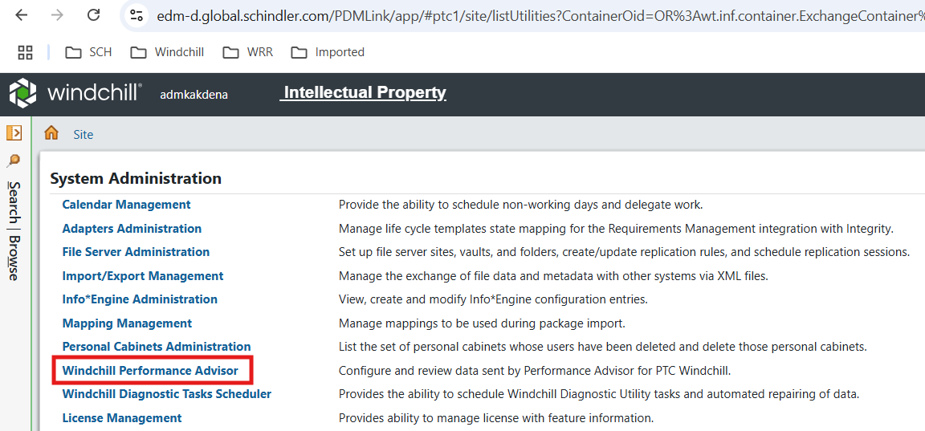
- Check GUID of target server. cf90950845969400da17c75b61dd2a9e3b9627c9 is the source server GUID.
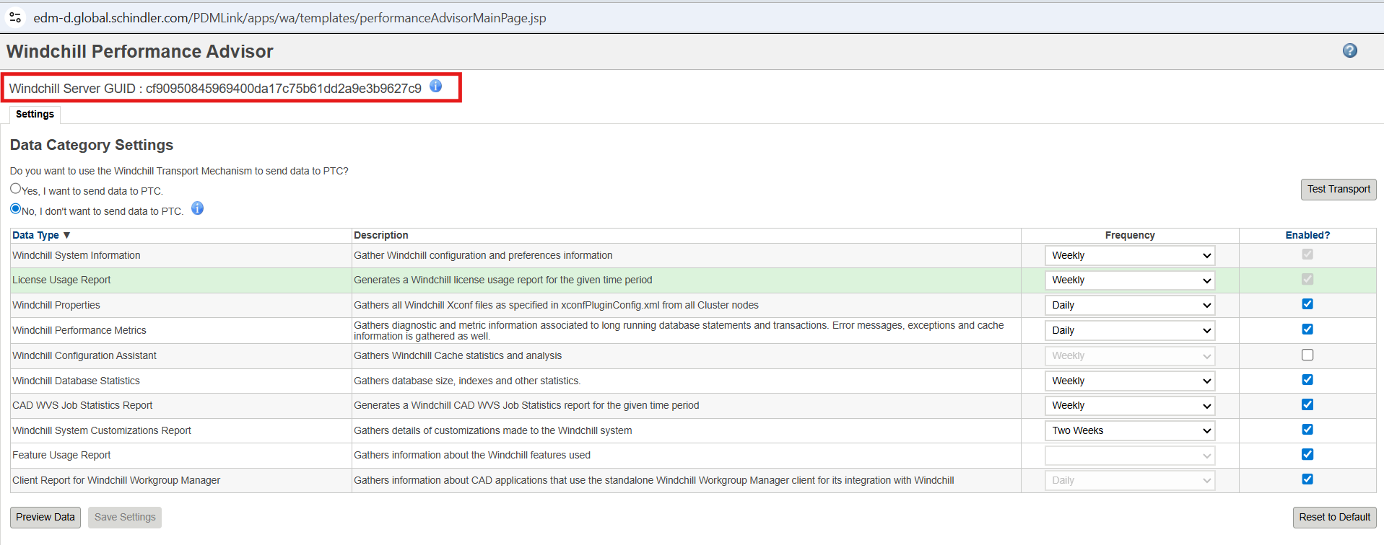

Delete Existing GUID
- Log to database SSHWSR2915using pdmlink user
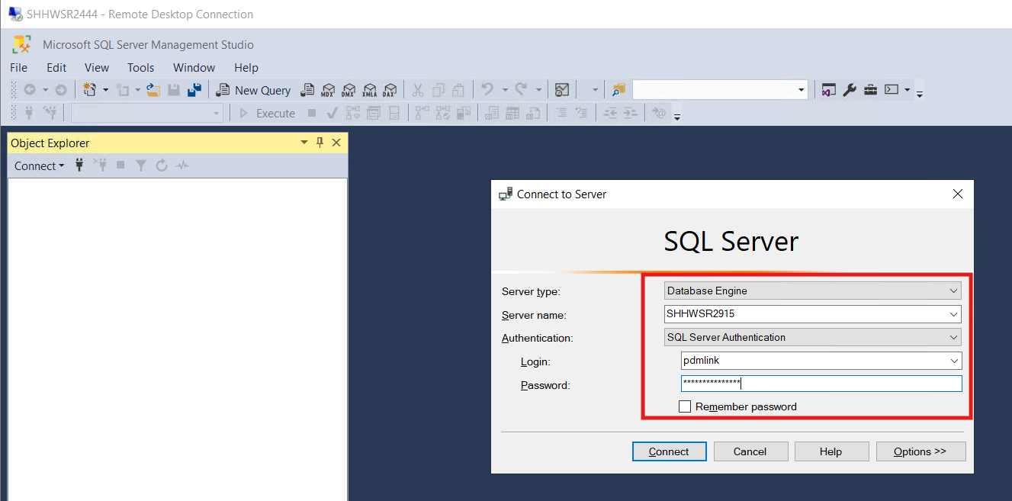
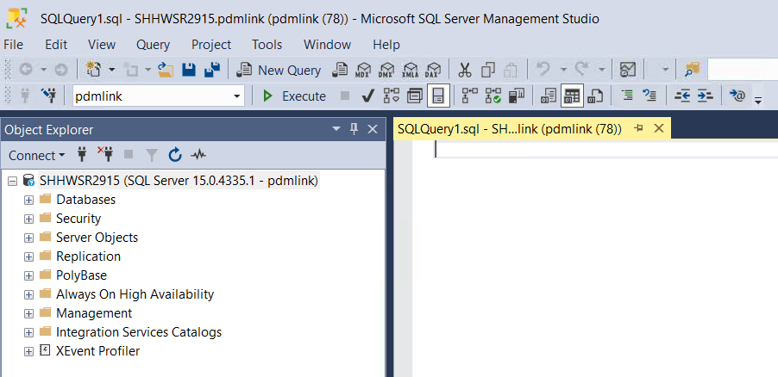
- Validate you are connected to correct database by executing below query
select * from FvHost;
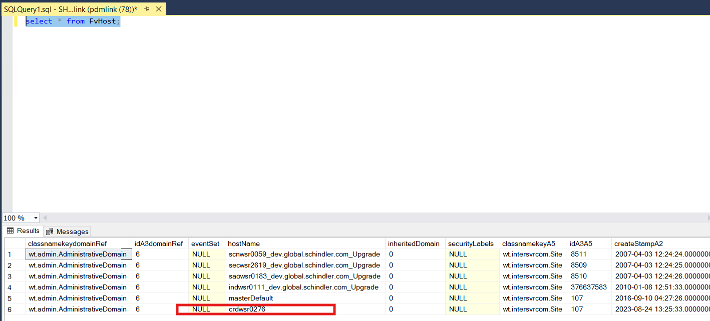
select * from Site;
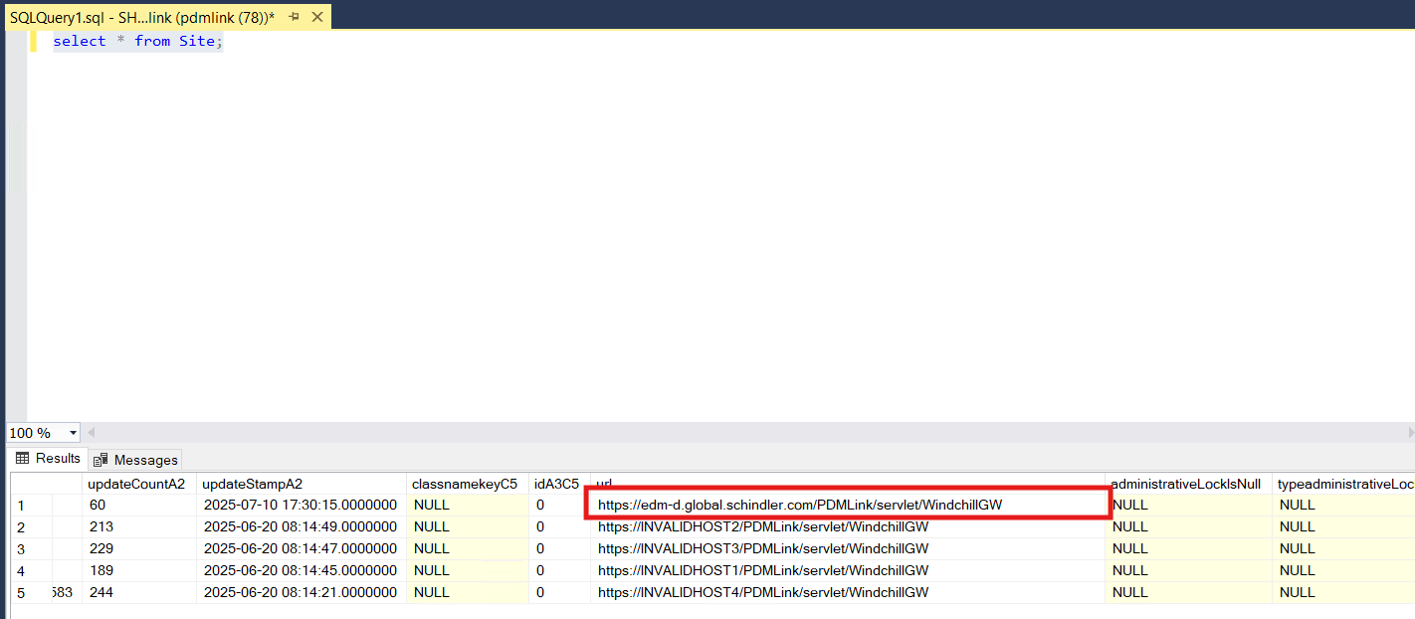
- Take backup of Repository table by executing below query
SELECT * INTO Repository_23072025 FROM Repository ;
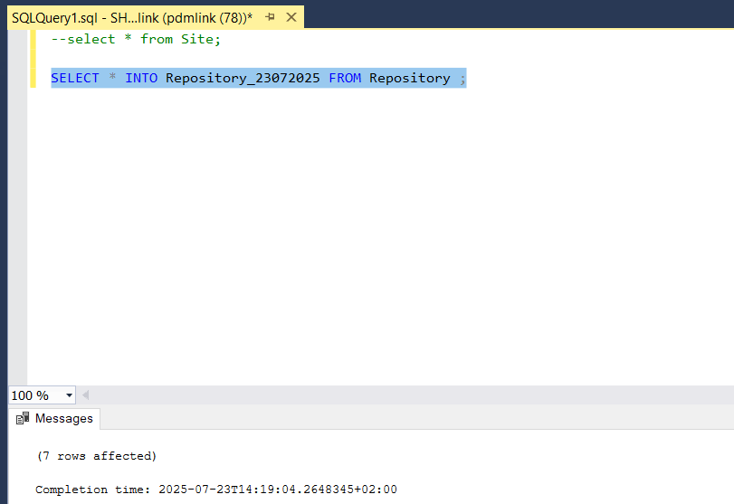
- Validate backup table is created by executing below query.
select * from Repository_23072025;
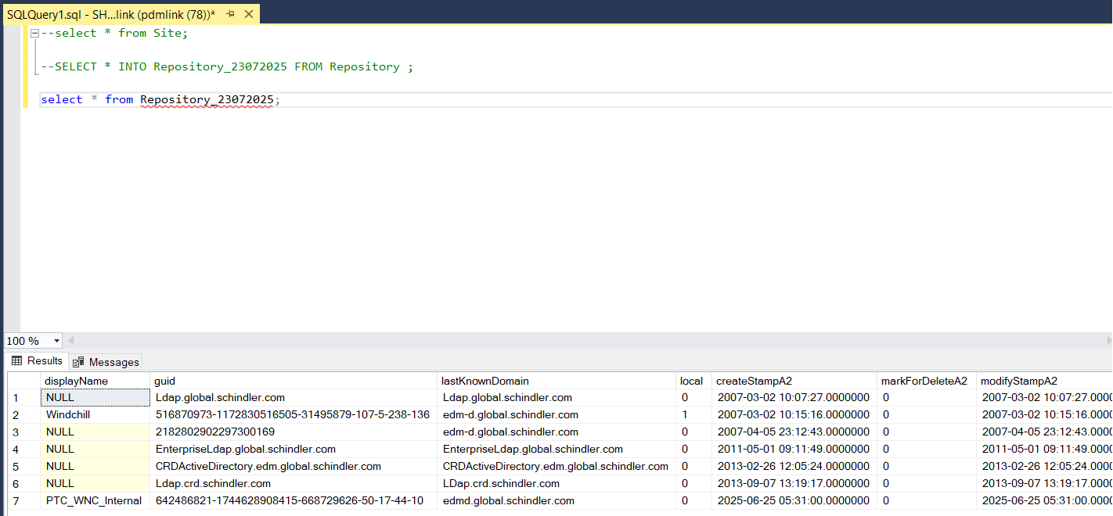
- Copy ida2a2 value of displayName PTC_WNC_Internal rows and execute below query
delete from Repository where idA2A2='23920539658';
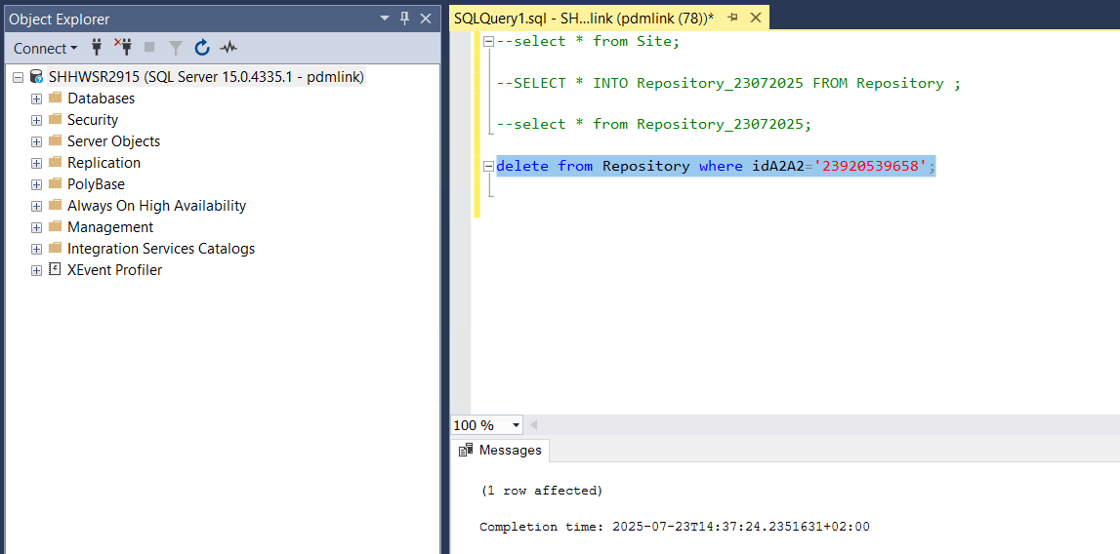
- validate entry is deleted using below query
select * from Repository;
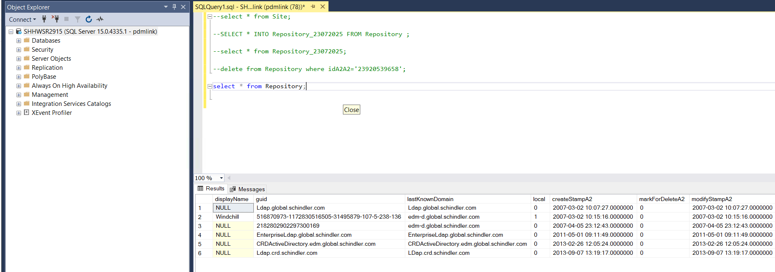

Generate new GUID
- To generate a new WPA GUID for a target system run the following command from a Windchill shell on the target system
windchill com.ptc.wa.WAUtility -generateguid -username=<username> -password=<password>
where:
<username> is a Windchill admin username
<password> is the Windchill admin password
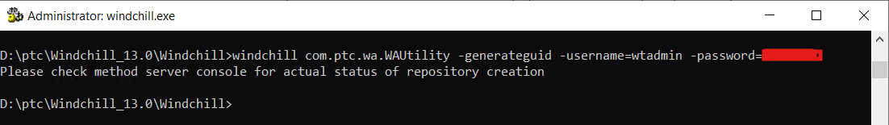
- Validate new GUID is updated in Site > Utilities > Windchill Performance Advisor
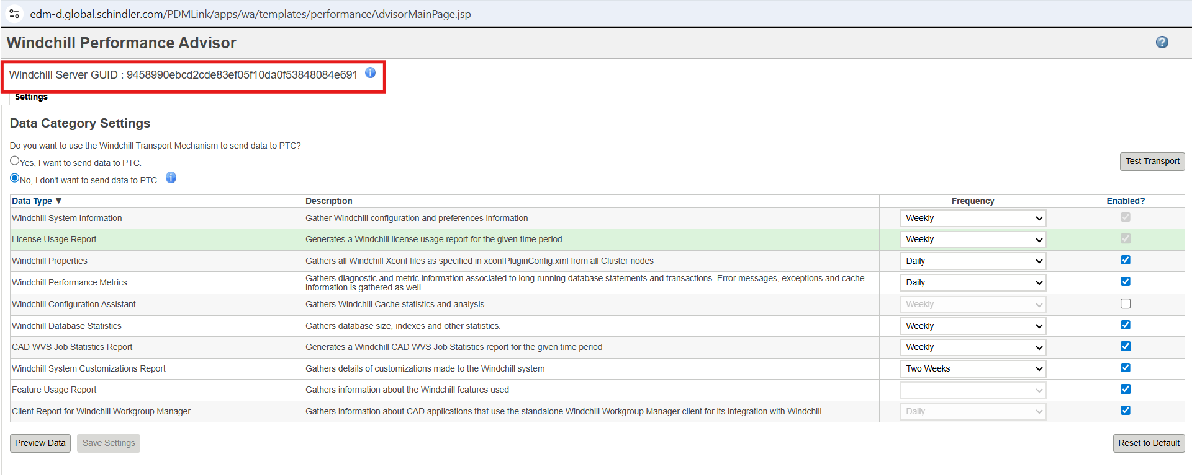
9458990ebcd2cde83ef05f10da0f53848084e691 is the new GUID for target server
- Run below query in database to confirm new PTC_WNC_Internal rows in created
select * from Repository;
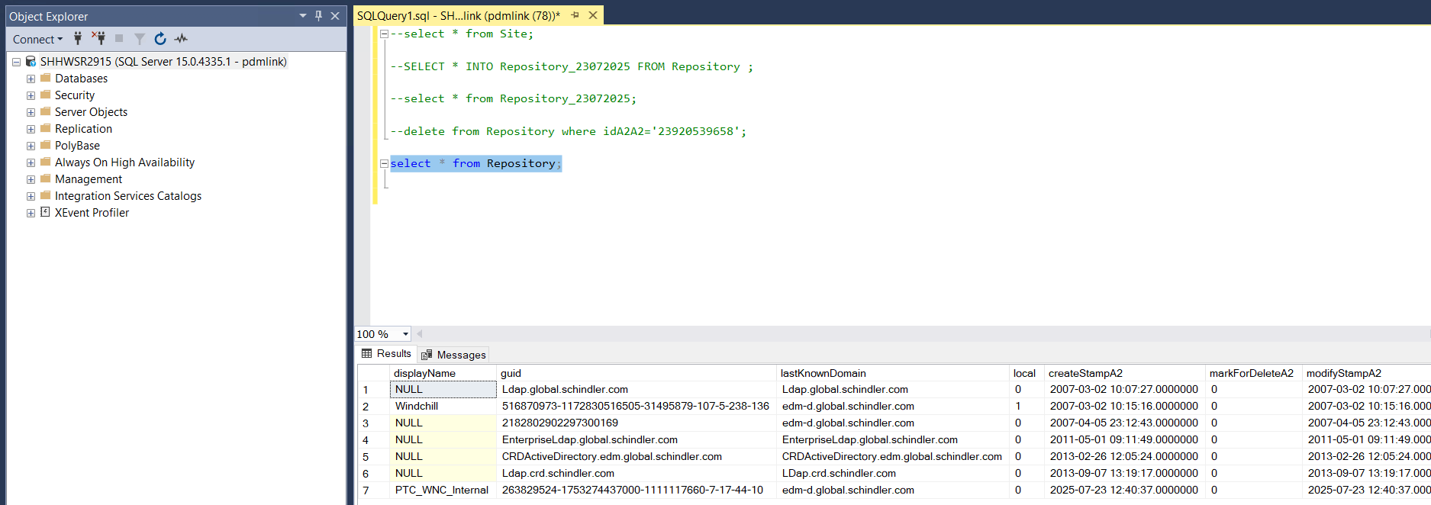

Enable Performance Advisor
Navigate to Site > Utilities > Preference Management
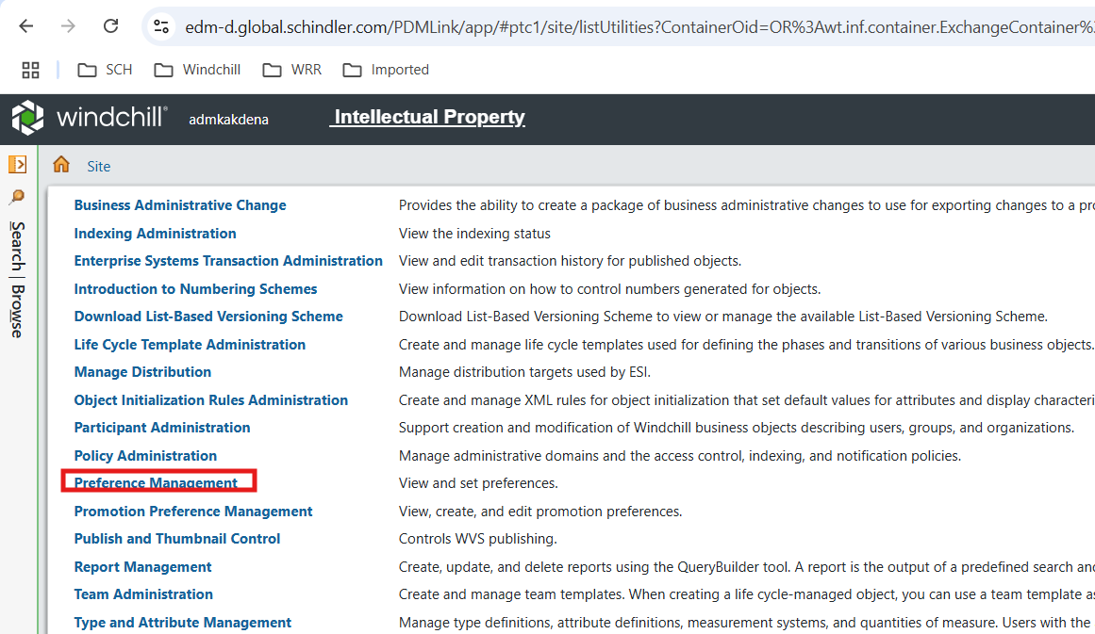
- Set Windchill Performance Advisor Activation preference value to Yes
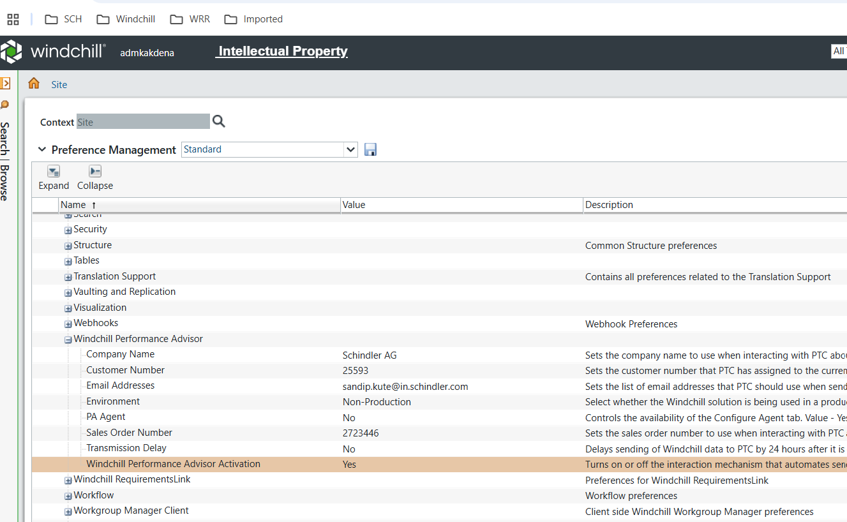

Test Transport
- Navigate to Windchill Performance Advisor Dashboard and Click on Test Transport

Validate WPA Dashboard
- Data on WPA dashboard is available post 24 hours after enabling the WPA
- Log in to PTC eSupport portal and Click on Performance Advisor - System Dashboard
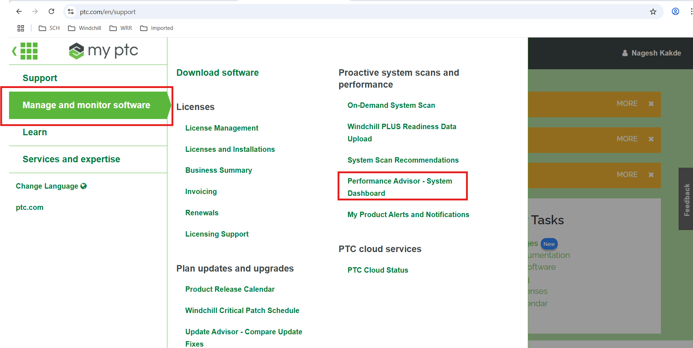

Issues and Resolution

Test Transport Failed

Issue
- Test Transport failed after clicking on Test Transport from Windchill Performance Advisor
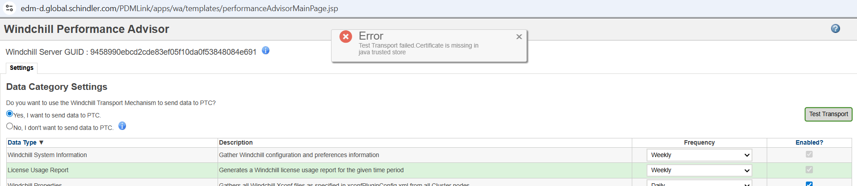
- Error in MS logs
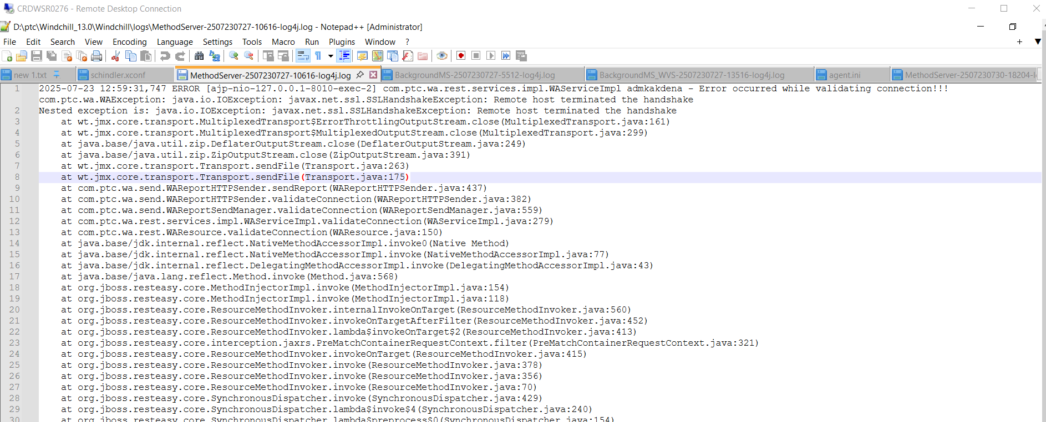

Resolution
- Open a Windchill shell, and move to the directory Apache\bin
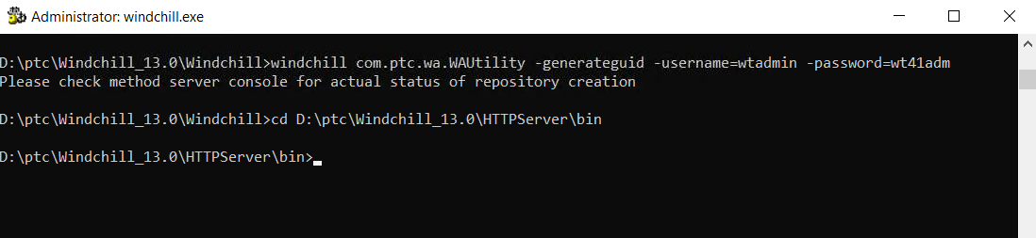
- Run: openssl
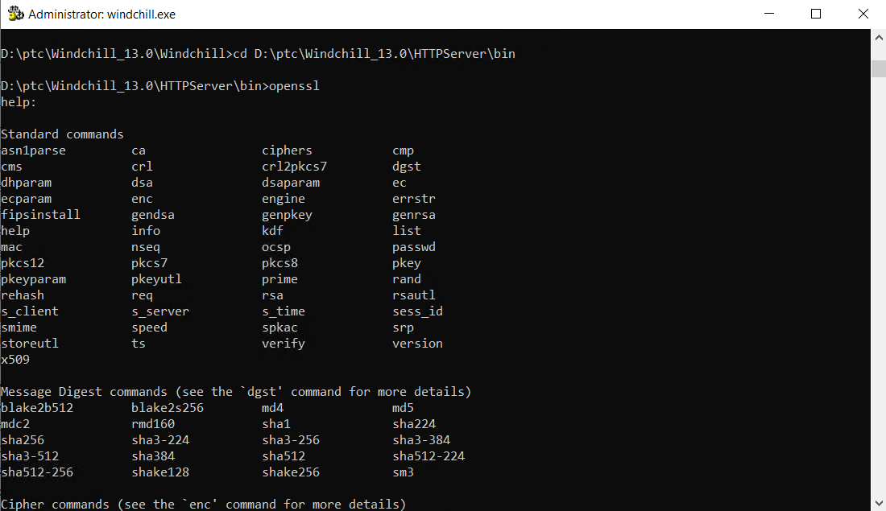
- Run s_client -connect apps.ptc.com:443
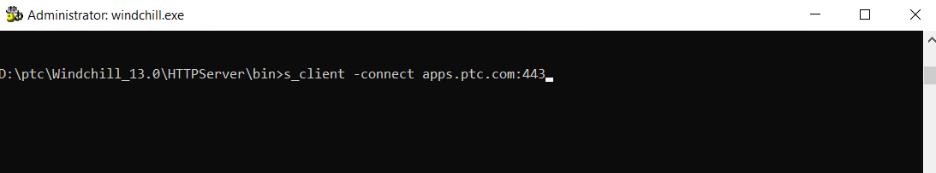
- This gets the certificate information, copy the section of text beginning with
----BEGIN CERTIFICATE---- through ----END CERTIFICATE----
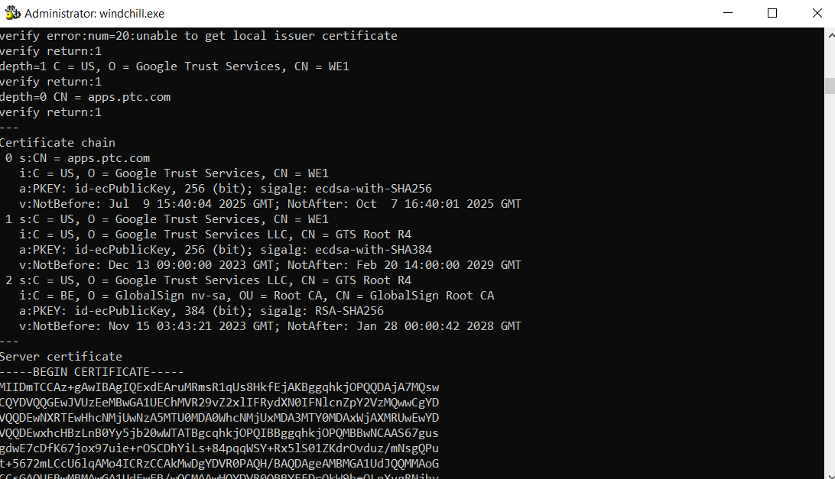

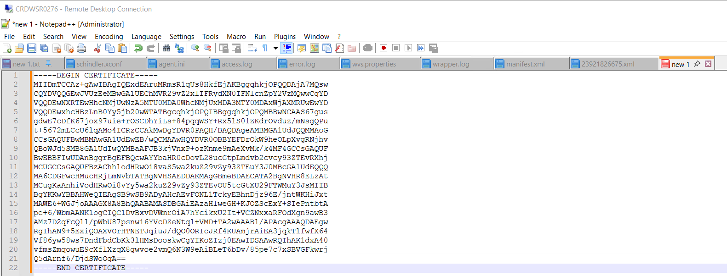
- save it as apps_ptc_com.cer
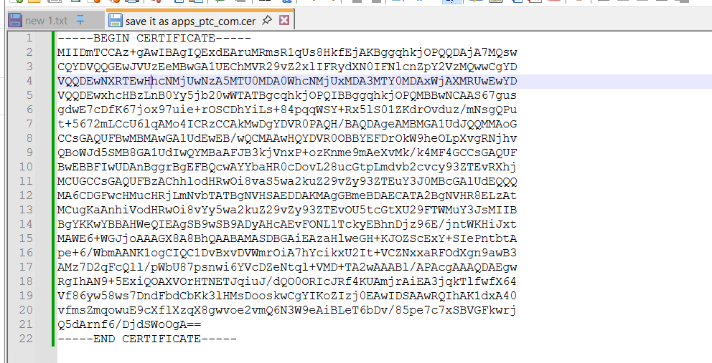

- Import this certificate into java certificate store using the following command:
keytool -import -alias PTC -file "D:\ptc_staging\wpa\apps_ptc_com.cer" -storetype JKS -keystore D:\ptc\Windchill_13.0\Java\corretto\jdk17.0.11_9\lib\security\jssecacerts -storepass changeit
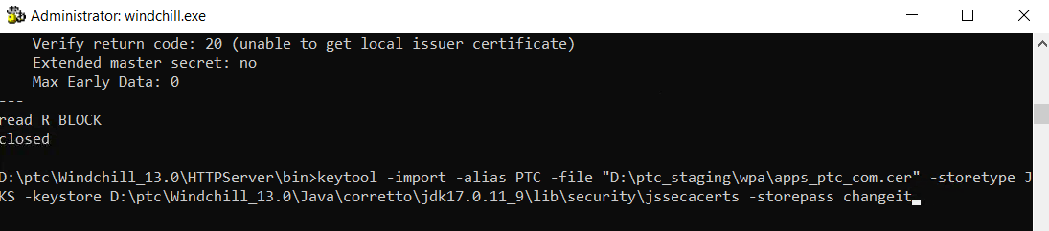

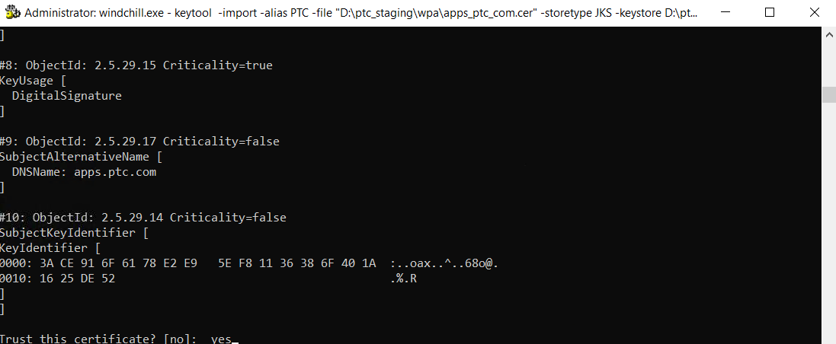

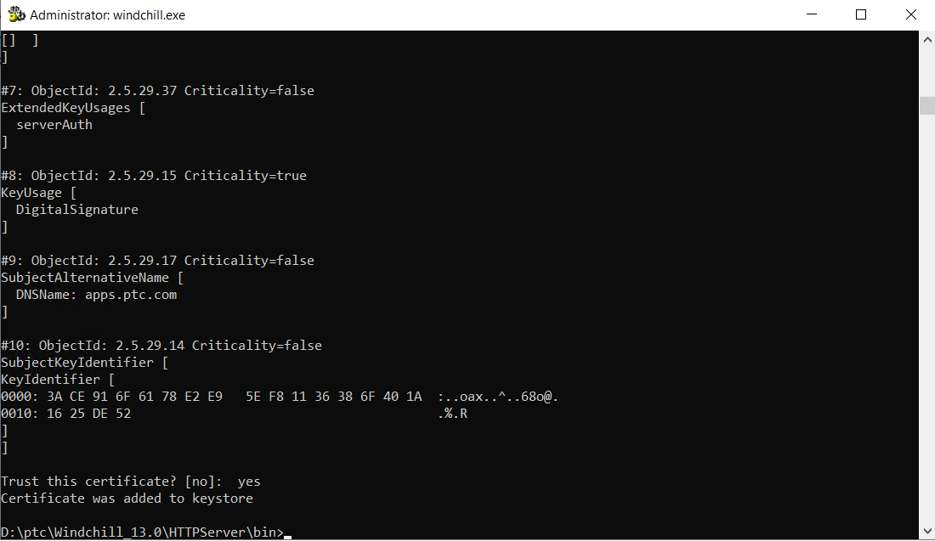
- Restart Windchill and test Transport from Site > Utilities > Windchill Performance Advisor
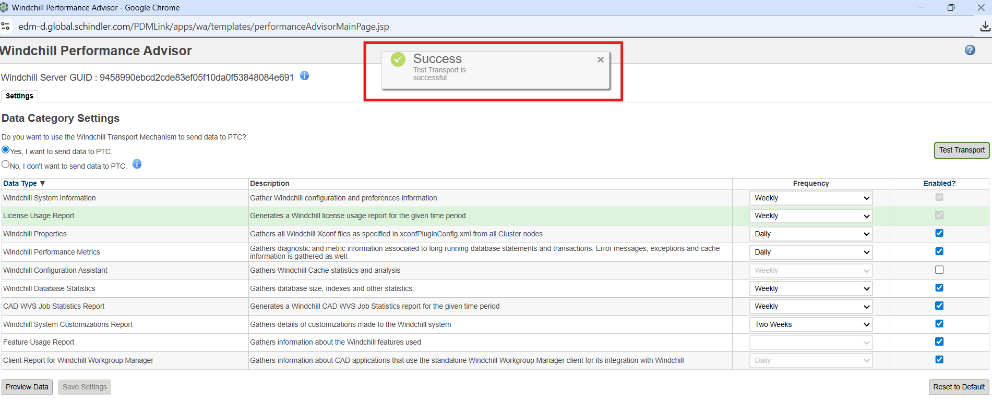

References
- SQL Queries
--select * from Site;
--SELECT * INTO Repository_23072025 FROM Repository ;
--select * from Repository_23072025;
--delete from Repository where idA2A2='23920539658';
--select * from Repository;
- PTC Case
https://support.ptc.com/app/caseviewer/?case=17885738&source=casetracker
- PTC Articles
https://www.ptc.com/en/support/article/CS236036
https://www.ptc.com/en/support/article/CS236189

